AITSE 0712

NATIONAL TEACHERS COUNCIL
ALL INDIA TALENT SEARCH EXAMINATION: 2012

CLASS VII

Duration: 90 Minutes Maximum Marks: 100
General Instructions to Candidates
1. This question paper contains 100 multiple choice questions each of one mark.
2 The question paper is divided into two sections, A and B
3. Section A is Scholastic Aptitude Test (SAT), contains 60 questions. This section covers Physics, Chemistry, Biology and Mathematics.
4. Section B is Mental Ability Test (MAT), Computer Awareness and General Knowledge, contains 40 questions.
5. There will be no negative marks for wrong answer.
6. A separate answer sheet is provided for answering the questions. Each question should be answered by darkening the appropriate circle (A, B, C, or D) with a blue or black ball pen.
7. Answer recorded once in the answer sheet cannot be altered.
8. All rough works should be done only in the space provided for rough work in this question paper.
9. Calculator is not permitted in the examination hall.
10. Candidate should write his / her name in the space provided for the purpose.

Name

SECTION A

1. When steel rod is heated it becomes
A) Lighter B) Heavier C) Little longer D) Little shorter
2. The speed of sound varies from medium to medium. In what order does the speed of sound increases in these media?
A) Steel, Water, Air B) Air, Steel, Water
C) Water, Air, Steel D) Air, Water, Steel
3. Identify the odd one:-
A) Electric Current B) Battery C) Galvanometer D) Electric Fuse
4. 140$°$F is equal to ………………$°Celsius$
A) 273 B) 140 C) 100 D) 60
5. On blowing air into balloon, the size of the balloon increases, because
A) Warm air rise up B) Air exert pressure
C) Air is gas D) Air is stronger than balloon
6. The distance-time graph of a body is parallel to time axis. This graph represents a body at
A) Uniform motion B) Uniform acceleration
C) Rest D) Non-uniform motion
7. A body is in to and fro motion. This is an example of
A) Oscillatory motion B) Periodic motion
C) Circulatory motion D) Both (A) & (B)
8. Read the following statements carefully and mark the correct option
P A current carrying conductor experiences a force in a magnetic field
Q A current carrying conductor produces a magnetic field around it
A) Statements P & Q are correct B) Statements P & Q are wrong
C) Statement P is correct & Q is wrong D) Statement P is wrong & Q is correct

9. An appliance which does not use electromagnet
A) Washing machine B) Electric heater C) Electric bell D) Grinder
10. A light ray falls perpendicular to the surface of a plane mirror. The angle of reflection is
A) 180$°$ B) 90$°$ C) 0$°$ D) None of these
11. The reflecting surface of a mirror is curved inward. The nature of the image formed by the mirror is
A) Always real B) Always Virtual. C) Neither real nor virtual. D) Either real or virtual
12. Different types of cells are used for different purposes due to their advantages. What is the advantage of accumulator over a dry cell?
A) Leak proof B) Rechargeable C) Cheap D) Potable
13. A bullet is fired from a gun straight up. The energy change taking place as the bullet goes up
A) Kinetic energy to Potential energy B) Potential to kinetic energy
C) Kinetic to chemical D) Both (B) & (C)
14. If you rub two balloons with your hair and bring them together, they will be
A) Burst B) Attract each other
C) Repelled by each other D) Remained unaffected
15. Which of the following determines the loudness of sound?
A) Amplitude B) Frequency C) Wavelength D) Velocity
16. Study the classification give below
Natural Resources

Sunlight, Water, Air
Soil, Forest, Groundwater
The above classification is done on the basis of
A) Renewable & Non renewable resources B) Inexhaustible & exhaustible resources
C) Both (A) & (B) D) None of these
17. During the formation of rain, when water vapour changes into liquid water, heat is
A) Absorbed B) Released
C) First absorbed & then released. D) Neither absorbed nor released

18. The rusting of ships leads to huge monetary loss in shipping industry. The rusting is due to
A) The air around is very humid B) The salt water speed up rusting
C) The ship is always in contact with water D) All the above
19. Which one is combustible?
A) Carbon dioxide B) Oxygen C) Hydrogen D) Both (B) & (C)
20. The properties of one of the fabrics are listed below. Identify the fabrics.
It is cool to wear, absorbs water easily, soft to touch, crease easily, can be washed & ironed easily.

A) Wool B) Cotton C) Silk D) Nylon
21. Carefully read the below given statements and mark the correct option.
P Metals on burning produces metallic oxides.
Q A solution of metallic oxides in water turns blue litmus red.
A) Both the above statements are true B) Both the above statements are false
C) Statement P is false & Q is true D) Statement P is true & q is false
22. A reaction between acid and base to form salt and water is called
A) Neutralization reaction B) Decomposition reaction
C) Displacement reaction D) Redox reaction
23. Tamarind is sour in taste. This is due to the presence of
A) Lactic acid B) Citric acid C) Tartaric acid D) Hydrochloric acid
24. The element hydrogen burns in oxygen to form new substance. The new substance formed is
A) Element B) Compound C) Mixture D) Either (A) or (B)
25. Lime water is a solution of
A) Sodium chloride in water B) Sodium hydroxide in water
C) Calcium chloride in water D) Calcium hydroxide in water

26. Read the following informations and identify X and Y
- X & Y are components of blood.
- X produces antibodies
- Y helps in blood clotting.
A) X-Platelets; Y-WBC
B) X-RBC; Y-Platelets
C) X- Plasma: Y- Platelets
D) X- WBC; Y- Platelets
27. Read the below given informations carefully and identify the organism.
- Reproduces by budding
- Respire anaerobically.
- Used to make wine

A) Yeast B) Grapes
C) Potato D) Mucar

28. Which of the following organ is excretory in function?
A) Liver B) Skin C) Kidney D) All of these
29. Why do we have muscular cramp after strenuous exercise?
A) Due to accumulation of lactic acid B) Due to breakdown of glucose
C) Due to slow circulation of blood D) due to muscle cells respiring aerobically
30. Which of the following gives sexual reproduction an advantage over asexual reproduction?
A) Produces more offspring’s B) Ensures the survival of the species
C) Preserves parental gene type D) Increases the variation among the offspring of
an individual
31. Which of the following exhibits photosynthesis?
A) Roots B) Mimosa leaves C) Sunflower D) Stem
32. Identify the food items that are rich in starch.
A) Potato & Wheat B) Bread & Milk C) Meat & Banana D) Butter & Groundnut
33. The leaves are arranged in different ways in different plants to get maximum exposure to the sun light. This arrangement is known as
A) Venation B) Phillotaxy C) Geotropism D) Phototropism
34. The largest gland in our body
A) Thyroid B) Kidney C) Salivary D) Liver
35. Identify the correct order of transportation of water from the soil to the leaf of a plant.
A) Root, Root hair, Phloem, Leaf B) Root, Xylem, Phloem, Leaf
C) Root hair, Root, Xylem, Leaf D) Root hair, Root, Phloem, Leaf
36. Two circles with same centre and different radii are called
A) Congruent circles B) Concurrent circles C) Concentric circles D) Coplanar circles
37. If A earns 25% more than B, then how much does B earn less than A?
A) 15% B) 20% C) 21% D) 25%
38. A & B can do a piece of work in 8 days, B & C in 6 days and A&C in 12 days. In how many days can all of them working together complete the work?
A) 6 days B) 9days C) 2$\frac{1}{3}$ days D) 5$\frac{1}{3}$ days
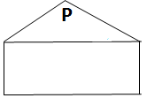
39. The below given figure shows one side of Arya,s home.
What is the measure of angle P in degree? 40 40
A) 100 B) 80
C) 180 D) 40
40. Out of isosceles triangles with sides of 7cm, and a base with the length expressed by whole number, the triangle with the greatest perimeter selected. The perimeter of the triangle is
A) 21cm B) 27cm C) 14cm D) 15cm
41. If $a+\frac{1}{a }$ = 2, then $a-\frac{1 }{a }$ is equal to
A) 4 B) -2 C) 2 D) 0
42. The diagram given below shows 4 number cards. Find which two number cards have digit 3 same values?
P Q R S
1.30

4.103

5.130

0.03

A) P and S B) P and R C) P and Q D) Q and R
43. The median for the set of numbers 1, 2, 3, 4, 8, 2 and P is 3. Then P cannot be
A) 5 B) 3 C) 2 D) 4

44. If ab = 1 then $\frac{1}{{1+a}^{-1}}+ \frac{1}{{1+b}^{-1} }$ is
A) 0 B) 1 C) a-b D) a + b
45. At what rate percent per annum will a sum of money double in 8 years?
A) 12$\frac{1}{3 }\%$ B) $3\frac{1}{3 }\%$ C) 3$3 \frac{1}{3 }\%$ D) 3$\frac{1}{2}\%$
1 | -10 | 0
A | -3 | -2
-6 | 4 | B
46. In the magic square given below each row, column and diagonal have same sum. The value of A and B are respectively
A) -7, -4 B) -4, -6
C) -6, -4 D) -4, -7
47. The sign of product of two unlike integers is
A) Negative B) Positive C) Positive or negative D) Cannot be determined
48. A farmer has 192 animals out of which $\frac{7}{16 }$ are cattle. $\frac{2}{3 }$ of cattle are dairy cows. How many dairy cows he has
A) 128 B) 84 C) 56 D) 112
49. A rational number $\frac{-2}{ 3 }$
A) Lies to the right side of 0 on the number line B) Lies to the left of 0 on the number line
C) It is not possible to represent on the number line D) Cannot be determined where it lies
50. In a two digit number, ten’s digit is twice the unit’s digit. The number formed by interchanging the digits is 36 less than the original number> the number is
A) 48 B) 70 C) 72 D) 84
51. If two supplementary angles differ by 44⁰, then one of the angles is
A) 112⁰ B) 102⁰ C) 72⁰ D) 65⁰
52. An angle 45⁰ less than two times of its supplement, then the greater angle is
A) 75⁰ B) 10⁰ C) 105⁰ D) 120⁰
53. The sides of a triangle are 6.5cm, 10cm and s, where s is a whole number. What is the smallest possible value for s?
A) 3cm B) 3.2cm C) 3.4cm D) 4cm

54. The supplement of an acute angle is …………… angle.
A) Obtuse B) Acute C) Right D) A straight
55. The three angles of triangle are in the ratio 1:2:1.the greatest angle is
A) 45⁰ B) 90⁰ C) 60⁰ D) 120⁰
56. Two numbers are in the ratio of 1:2. If 7 be added to both, their ratio changes to 3:5. The greater number is
A) 36 B) 32 C) 28 D) 25
57. What is 50% of a number whose 200% is 20?
A) 20 B) 15 C) 10 D) 5
58. If 2l - 3m = -1 and lm = 20, then the value of ${4l}^{2}+{9m}^{2}$ is
A) 241 B) 240 C) 239 D) 361
59. In a parallelogram ABCD, diagonal AC measures34m and the perpendicular distance of AC from either of vertices B and D is 12 m. Area of parallelogram is
A) 816m² B) 204m² C) 402m² D) 408m²
60. The number of factors of 75 is
A) 10 B) 8 C) 6 D) 4
SECTION B

61. Find the odd term out:
A) Mouse B) MICR C) OCR D) Cursor
62. Click the ‘Back’ button as you move around the internet will usually send you:
A) To the last page visited B) To the home page
C) To close internet application D) to the list of book marks
63. Which one of the following is not an input device?
A) Keyboard B) Mouse C) Printer D) Joy stick
64. Which one of the following is not an example of hardware?
A) M S Office B) Keyboard C) Hard disk D) Monitor
65. Control Panel does not contain:
A) Date and Time B) Fonts
C) Add hardware D) Display
66 Which one of the following is not a input device?
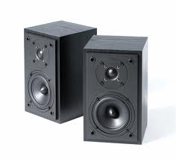
A) B) C) D)
67. If you want to type a mail which one of the following button you will click
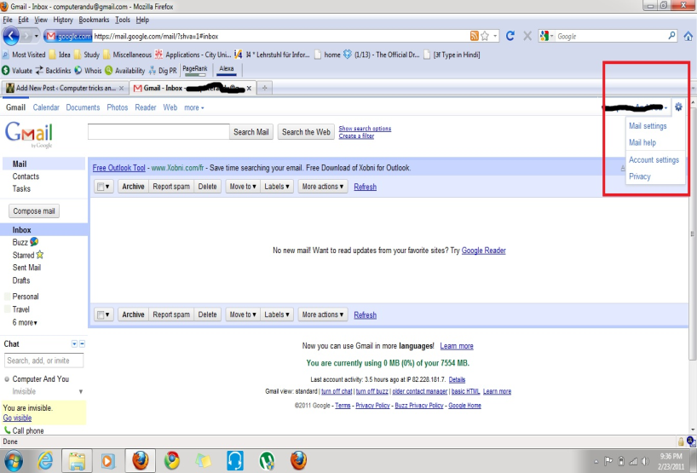
B)
C)
D)
A)
68. Which cereal is the staple food of ¹/₃ of the world population?
A) Rice B) Wheat C) Jowar D) Bajra
69. Who is the creator of “Tom and Jerry”?
A) Lee Walker B) Bruce Wayne C) Fred Quimby D) Stan Lee
70 Third Battle of Panipat was fought between
A) Babar and Ibrahim Lodhi B) Ahmed Shah Abdali and the Marathas
C) Babar and Hemu D) Akbar and Hemu

71. Which among the following is not a source of renewable energy?
A) Hydro electricity B) Wind energy
C) Nuclear energy D) Coal
72. The international airport in Tamil Nadu is?
A) Meenambakkam B) Indira Gandhi
C) Palam D) Netaji Subash Chandra Bose
73. During the time of which Mughal Emperor did the English East India Company establish its first factory in India?
A) Akbar B) Aurangzeb
C) Shahjahan D) Jahangir
74. Which of the following award is given for excellence in the field of sports?
A) Kalidas samman B) Dyanchand Award
C) Shram Vir Award D) Grami Award
75. North Eastern states of India also known as seven sisters. They include:
A) Mizoram, Tripura, Assam, Meghalaya , Sikkim, Arunachal Pradesh, Nagaland
B) Mizoram, Tripura, Assam, Meghalaya , Sikkim, Arunachal Pradesh, Bihar
C) Mizoram, Tripura, Assam, Chhattisgarh, Sikkim, Arunachal Pradesh, Nagaland
D) Mizoram, Tripura, Assam, West Bengal, Sikkim, Arunachal Pradesh, Nagaland
76. Choose odd one out:
A) Babar B) Sher Shah C) Shajahan D) Humayun
77. The following picture shows the interior structure of the earth. What will be the temperature of marked region?
A) 900⁰C to 1200⁰C
B) 1000⁰C to 2000⁰C
C) 2200⁰C to 5500⁰C
D) 9000⁰C to12000⁰C
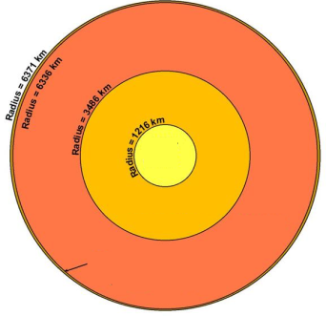

78. National Emblem of India is related to which one of the following ruler?
A)Chatrpati Shivaji
B) Ashoka
C) Samudra Gupta
D) Akbar
79. The classical dance form ‘Kathakali’ originated in which Indian states?
A) Orissa B) west Bengal C) Karnataka D) Kerala
80. Which one of the following rock is known as primary rock?
A) Granite B) Igneous
C) Sedimentary D) metamorphic
81. 2018 FIFA World would be held in:
A) Russia B) Qatar
C) France D) Germany
82. Who gave the slogan “Inquilab Zindabad”?
A) Subhash Chandra Bose B) Bhagat Singh
C) Iqbal D) Chandrasekhar Azad
83. Who is rightly called the “Father of Local Self Government”?
A) Lord Mayo B) Lord Ripon
C) Lord Curzon D) Lord Mount Baton
84. Who among the following started the ‘Slave Dynasty’?
A) Ghiyasuddin Tughlaq B) Balban
C) Qutubuddin Aibak D) Iltutmish
85. Who was the founder of Mughal Empire?
A) Akbar B) Babar
C) Sher Sha D) Aurangazeb
86. ‘Lead’ is related to ‘Pencil’ in the same way as ‘Ink’ is related to:
A) Bottle B) Pen C) Stamp D) Colour

87. How many meaningful English words can be made from the letters IRA, using each letter only once in each word
A) None B) Two C) One D) More than three
Direction for question No 88 to 90:- In each of the following questions four words or letters have been given of which three are alike in some way and one is different. Choose out the odd one.
88. A) India, B) Afghanistan, C) Nepal D) Egypt
89. A) Crust B) Mantle C) Core D) Atmosphere
90. A) AC B) EG C) RS D) WY
91. If ‘A’ means ‘+’, ‘B’ means ‘x’, ‘c’ means ‘—‘ and ‘D’ means ‘÷’ then:
1 2 B 8 C D 2 A 4 = ?
A) 89 B) 97 C) 84 D) 90
92. ‘AB’ is related to ‘EF’ in the same way ‘IJ’ is related to
A) MN B) KL C) OP D) NO
93. In certain code ‘AEROBIC’ is written as ‘BFQNAJD’. How is ‘ADVERTS’ written in that code
A) BEQUDUT B) BEDUDQUT C) BEUDSUR D) STREVDA
94. Five boys Rakesh, Anil, Mahesh, Suresh and Manjit are sitting in a circle.
1. Anil is sitting between Rakesh and Suresh
2. To Manjit’s right Suresh is seated. Who is seated to Mahesh’s left?
A) Anil B) Rakesh C) Suresh D) Manjith
95. In certain code ‘FAITH’ is coded as ‘HCKVJ’ and NIGHT is coded as’ PKIJV’. In the same code KRONP will be coded as:
A) MTQOR B) MTQRO
C) MQTOR D) MTQOM
96. Which of the following will come in place of question mark?
XVU WUT VTS USR ?
A) TSQ B) SQP C) TVW D) TRQ

Directions (Q.No.97 to 99) study the following table carefully and answer the question given below:-
General land use categories in percentage
Use | 1960 - 1961 | 2002-03
Forest | 18.11 | 22.57
Net sown area | 45.26 | 43.41
Barren and waste land | 12.01 | 6.29
Area under non agriculture use | 4.95 | 7.92
Permanent pasture and Grazing land | 4.71 | 3.45
Area under misc. tree crops and groves | 1.50 | 1.10
Culturable wasteland | 6.23 | 4.41
Fallow other than current fallow | 3.50 | 3.82
Current fallow | 3.73 | 7.03
Total | 100 | 100
97. Find the difference of land use under forest area in 2002 -03 compared to 1960 -61
A) It is decreased to 4.46 B) It increased to 4.46
C) No change D) Can’t Say
98. Net sown area decreased from 45.26% to 43.41%, mainly because of:
A) More agriculture area used for construction works
B) Agriculture area used for settlement.
C) Agriculture area used for urbanization
D) All of the above
99. In 2002 - 03 Land utilization increased in:
A) Current fallow, Other than current fallow, Area under non agriculture use and Net sown area
B) Current fallow, Other than current fallow, Area under non agriculture use and Forest
C) Current fallow, Area under non agriculture use, Culturable waste land and Forest
D) Other than current fallow, Area under non agriculture use and Forest
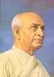
100. Identify this great freedom fighter.
A) Sardar Vallabai Pattel
B) Rajendra Prasad
C) Dr. S Radhakrishnan
D) Balagangadhar Thilak

Space for Rough Works

Space for Rough Works

