AITSE 0912

NATIONAL TEACHERS COUNCIL
ALL INDIA TALENT SEARCH EXAMINATION: 2012
CLASS IX

Duration: 90 Minutes Maximum Marks: 100
General Instructions to Candidates
1. This question paper contains 100 multiple choice questions each of one mark.
2 The question paper is divided into two sections, A and B
3. Section A is Scholastic Aptitude Test (SAT), contains 60 questions. This section covers Physics, Chemistry, Biology and Mathematics.
4. Section B is Mental Ability Test (MAT), Computer Awareness and General Knowledge, contains 40 questions.
5. There will be no negative marks for wrong answer.
6. A separate answer sheet is provided for answering the questions. Each question should be answered by darkening the appropriate circle (A, B, C, or D) with a blue or black ball pen.
7. Answer recorded once in the answer sheet cannot be altered.
8. All rough works should be done only in the space provided for rough work in this question paper.
9. Calculator is not permitted in the examination hall.
10. Candidate should write his / her name in the space provided for the purpose.

Name

SECTION A

1. The velocity of a moving body becomes one – third of its initial velocity. The ratio between its initial and final kinetic energy is
A) 9 : 1 B) 1 : 9 C) 3 : 1 D) 1 : 3
2. A body thrown vertically up with a velocity of ‘u’ reaches the maximum height ‘h’ after T seconds. Which one of the following is true for the body?
A) Its velocity is u/2 at a height of h/2. B) Its velocity is u at T second.
C) Its velocity is –u at 2T second D) Its velocity is -6u at 2T second.
3. Two bodies of mass m₁ & m₂ are moving in circles of radii r₁ & r₂ respectively. Both the bodies take same time duration to complete the circle. The ratio of the angular speed of first body to second is
A) m₁ : m₂ B) r₁ : r₂ C) m₁r₁ : m₂r₂ D) 1 : 1
4. A body of 10Kg starts from rest and covers a distance of 20m in 4 seconds. The force acting on the body is
A) 50N B) 25N C) 500N D) 1000N
5. Read the following statements carefully and mark the correct option
P The inertia of a body is directly proportional to mass.
Q The force acting on a body is directly proportional to rate of change of momentum of
the body.
A) The statement P is true and Q is false B) The statement P is false and Q is true
C) Both the statements P and Q are true D) Both the statements P and Q are false
6. Which one of the following statements is correct?
A) The weight of body increases on moving from equator to pole of the earth.
B) The weight of body decreases on moving from equator to pole of the earth.
C) Weight of a body remains same everywhere on the earth
D) None of these.
7. A body weighs 22N in air, weighs 17N in a liquid. What is the relative density of the body?
A) 1 B) 1.25 C) 0.2 D) 0.8

8. An object moving at a particular height has equal potential and kinetic energies. If the object is at 20m from the ground, the velocity of the object is(take g=10ms⁻¹)
A) 20ms⁻¹ B) 10ms⁻¹ C) 5ms⁻¹ D) 100ms⁻¹
9. The wavelength of sound of frequency 550Hz travelling with a speed of 330m/s is
A) 60m B) 6m C) 0.6m D) 6cm
10. An electric heater of 1500W is used for 2 hours. The electric energy consumed is
A) 3000 J B) 3.6 X 10⁶ J C) 1.08 X 10⁶ J D) 1.08 X10⁷ J
11. Two iron balls of masses 2Kg and 6Kg are dropped from a height of 100m. After 50m their respective kinetic energies will be in the ratio of
A)$\sqrt{2}$ : 1 B) 1 : 3 C)1 : $\sqrt{3}$ D)1 : 2
12. The S.I unit of “Magnetic flux” is
A) Lux B) Henry C) Tesla D) Weber
13. What does the slope of a velocity time graph represent?
A) Acceleration B) Uniform Velocity C) Distance D) Momentum
14. Four forces acting on a body does not change its position and shape. The forces
A) Must be in single line. B) Must be parallel and opposite.
C) Must adds up to zero when taken as vector. D) Must be of equal in magnitude.
15. An iron body of mass 10Kg and volume 12.5 X 10⁻³ m³ is dipped in water. The body will
A) Float B) Sink
C) First float, then sinks D) None of these
16. Element X and Y react to form X_{a}Y_{b}. Element P and Q reacts to form P_{m}Q_{n}. The formula of the compound formed between X and Q is
A) X_{n}Q_{n} B) X_{b}Q_{m} C) X_{m}Q_{a} D) X_{m}Q_{b}
17. Greasy sports can be removed from cloths by
A) Sublimation B) Dissolving in a suitable solvent
C) Fractional distillation D) Filtration

18. What mass of oxygen gas will contain the same number of molecules as in 6gram of hydrogen gas?
A) 96 gram B) 64 gram C) 32 gram D) 6 gram
19. Read the following statements and mark the correct option.
P Isotopes are identical in chemical properties.
Q Isotopes have same mass number.
A) Statement Q is the correct explanation for P
B) Both the statements P & Q are false
C) Statements P & Q are true, but Q is not the correct explanation for P
D) Statement P is true and Q is false.
20. An ion X³⁻ contains 10 electrons and 7 neutrons. The atomic number and mass number of X are respectively
A) 10 & 7 B) 10 & 17 C) 7 & 14 D) 7 & 7
21. In which of the following substance the force of attraction is minimum.
A) Dry air B) Glycerin C) Kerosene D) Gold
22. Which of the following obeys “law of constant proportion” in their formation?
A) Colloid B) Element C) Compound D) Mixture
23. How many moles of water makes 90gram of water?
A) 10 B) 5 C) 0.1 D) 0.5
24. Name the radioactive radiation that travels with the speed of light.
A) Alpha radiation B) Beta radiation
C) Gama radiation D) All of these
25. The chemical formula of Sulphurous acid is
A) HCl B) HNO₃ C) H₂SO₄ D) H₂SO₃
26. A dominant group of land plant is
A) Angiosperm B) Gymnosperm C) Bryophytes D) Pteridophytes

27. Cynobacteria are included in
A) Fungi B) Bacteria
C) Algae D) Viruses
28. Which one of the following is NOT paired correctly?
A) Endoplasmic reticulum : Protein synthesis
B) Golgi complex : Breakdown of complex molecules
C) Chloroplast : Photosynthesis
D) Mitochondria : Production of ATP
29. Which Meristem gives rise to vascular tissue?
A) Apical Meristem B) Special Tissue
C) Intercalmy Meristem D) Lateral Meristem
30. The cell walls of adjacent cells are joined together by a jelly like substance made up of calcium and magnesium pectate. This is called
A) Middle lamella B) Plasma lemma
C) Plasmodesmite D) Micro fibril
31. Chromosomes are composed of
A) DNA & Lipids B) RNA & Proteins
C) DNA & Proteins D) Both (A) & (C)
32. Read the following statements and mark the correct option.
P Tendons joins skeletal muscles to bones.
Q Ligaments connect bones to bones.
A) Both statements P and Q are false B) Both statements P and Q are true
C) Statement P is true & Q is false D) Statement P is false and Q is true.
33. These animals are cold blooded, have scales and breathe through lungs. They have four chambered heart. They lay eggs with tough coverings and do not need to lay eggs in water. Identify the animal.
A) Chameleon B) Lizard C) Tortoise D) Crocodile

34. Which one of the following is NOT correct?
A) Penicillin inhibits carbohydrate synthesis
B) All antibiotics have selected toxicity
C) Antibiotics causes little or more damage to the host
D) Streptomycin inhibits protein synthesis
35. Which one of the following is NOT an effect of water pollution?
A) Disturbance in ecological balance B) Biomagnifications
C) Eutrophication D) Silting of water reservoir.
36. The sum of interior angles of a polygon of 10 sides is
A) 1440 B) 720 C) 144 D) 36
37. You are given a cone and a cylinder of same heights and radii. If the volume of cylinder is 72cm³, the volume of cone is
A) 216 cm³ B) 144 cm³ C) 24 cm³ D) 9 cm³
38. The circumference of a circle is 396m. Then its area in square metre is
A) 14274 B) 14724 C) 17241 D) 12474
39. If ABC is a triangle and D, E and F are respectively midpoints of AB, BC and CA, then the triangle ABC is
A) Similar to $∆$DEF but not $∆$DBE B) Similar to $∆$DEF but not $∆$ECF
C) Similar to $∆$DBE, $∆$ECF, $∆$ADF and $∆$DEF D) Not Similar to $∆$DBE, $∆$ECF, $∆$ADF and $∆$DEF
40. The equation for the straight passing through the points (-1, 3), (0, 2) and (2, 0) is
A) y= x + 2 B) y = -x + 2 C) y = x – 2 D) None of these
41. In $∆$ABC, we have$<A$ > $<B$ > $<C$, then,
A) AB > AC B) AB < AC C) BC < AB D) None of these
42. Positive numbers a, b, c, d and e has the following property:-
ab = 2; bc = 3; cd = 4 and de = 5. What is the value of $\frac{e}{a}$ ?
A) 15/8 B) 5/6 C) 3/2 D) 4/5

43. A triangle and a rhombus are on the same base and between the same parallels. Then the ratio of the areas of the triangle and rhombus is
A) 1:1 B) 1:3 C) 1:2 D) 1:4
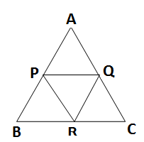
44. ABC is an equilateral triangle of side 4$\sqrt{3}$cm. P, Q and R are midpoints of AB, CA and BC respectively. The area of $∆$PQR (sq.cm) is
A) $\frac{\sqrt{3}}{4}$ B) $\frac{\sqrt{3}}{2}$
C) $2√3$ D) $3√3$

45. The cost prize of chair is Rs. 350. For how much should it be sold to gain 10%?
A) Rs.300 B) Rs. 385 C) Rs.415 D) None of these
46. Set of natural numbers is a subset of
A) Set of even numbers B) Set of odd numbers
C) Set of real numbers D) Set of composite numbers
47. If$x = \frac{\sqrt{3}}{4}$, then, $x^{3 }$+ $\frac{1}{x^{3 }}$ is
A) $\frac{ 91 \sqrt{3}}{72}$ B)$\frac{216\sqrt{3}}{72}$ C) $\frac{192\sqrt{3}}{72}$ D) None of these
48. Given that x = 2 is a solution of $x^{3 }– 7x+6=0.$ The other solutions of the equation are
A) -1, 3 B) -1, -2 C) 1, -2 D) 1, -3
49. Find the value of a if (x – a) is a factor of the polynomial $x^{6 }-ax^{5 }+x^{4 }–ax^{3 }+3x-a+2=0.$
A) a = 1 B) a = -1 C) a = -2 D) a = 2
50. Equation of the y – axis is
A) y = 0 B) x= 0 C) y = x D) y = -x
51. Two distinct points in a plane determines ………………………. Line.
A) Three B) Two C) Unique D) None of these

52. The angles A, B, C, D, in the parallelogram ABCD are
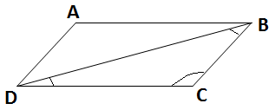
A) 90, 90, 90, 90
B) 90, 45, 30, 15 3a
C) 30, 60, 20, 40 2a 5a
D) 90, 45, 15, 20
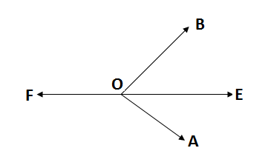
53. Ray OE bisects$<$ $AOB$ and OF is the ray opposite OE, then $<$ $FOB$ is
A) $<$ $FOE$ B) $<$ $BOE$
C) $<$ $AOE$ D) $<$ $FOA$

54. The locus of a point equidistant from the three vertices of a triangle ABC is
A) Excentre opposite to the vertex A B) Excentre opposite to the vertex B
C) Incetre D) Circumcentre
55. If the altitude of an equilateral triangle is $\sqrt{6}$ cm, its area is
A) $2\sqrt{6}$cm² B) $2\sqrt{2}$ cm² C) $3\sqrt{3}$ cm² D)$6\sqrt{2}$ cm²
56. If the radius of a sphere is doubled, then its volume is increased by
A) 700% B) 800% C) 100% D) 200%
57. The average of 9 numbers is 8. What should be added as 10th number to make the average9?
A) 90 B) 72 C) 10 D) 18
58. A bag contains 5 red balls and some blue balls. If the probability of drawing a blue ball is doubles that of red balls, find the number of blue balls in the bag.
A) 10 B) 5 C) 15 D) 20
59. A man is three years elder than his wife and four times as old as his son. If the son shall attain an age of fifteen years after three years, what is the present age of the mother?
A) 60 years B) 48 years C) 45 years D) 51 Years

60. The simple interest of X% for X years will be Rs. X on a sum of
A) (100/X) B) (100/X² ) C) X D) 100X

SECTION B

61. In Which type of memory, the content gets lost when the computer is switched off
A) RAM B) ROM C) Secondary Memory D) Pen Drive
62. While working with E Mail ‘cc’ stands for
A) Carbon Copy B) Carry Copy
C) A copy of another copy D) None of these
63. Which one of the following is not a font style?
A) Bold B) Italics C) Regular D) Subscript
64. Alta Vista, Lycos, and Yahoo are examples of:
A) Books B) Games C) Search Engines D) Operating System
65. ‘MPG’ extensions refers usually to the what kind of file?
A) MS Office document B) Word perfect document file
C) Animation/Movie file D) Image file
66. There are many services available within Internet for social networking. Which one
of the following is a room or online forum allows users to communicate through typed
messages which are displayed almost instantly.
A) Buddy B) Messaging
C) Mail D) Chat
67. HTTP stands for:
A) Hypertext Transfer Protocol B) Hyper Text Transfer Products
C) Hypertext Transport Protocol D) Hyper Transfer Terrestrial Products

68. Which one of the following has more memory capacity?
A) RAM B) ROM C) Floppy Disk D) Hard disk
69. Which one of the following act as interface between the user and the hardware?
A) Monitor B) Operating System
C) Programme D) Software
70. In laser printer printing is done by using:
A) Metallic Band B) Colored Ink cartridge
C) Laser beam and Toner D) Inkjet Cartridge
71. The Loka Sabha is superior to Rajya Sabha because:
A) It is directly elected by the people
B) The council of ministers accountable to it
C) It controls the budget
D) All of the above
72. Which of the following state of the Indian union has two capitals?
A) Arunachal Pradesh B) Jammu and Kashmir
C) Bihar D) Nagaland
73. The term ‘fourth estate’ refers to:
A) The Press B) Parliament
C) The Judiciary D) Backward caste in India
74. Which one of the following cities will never get the vertical rays of the sun?
A) Thiruvanandapuram B) Mumbai
C) Srinagar D) Kolkata
75. Madhya Pradesh shares its border with how many states?
A) 5 B) 3 C) 4 D) 6

76. In which one of the following islands of India is an active volcano found?
A) Kavarathi B) Nancowry Island
C) Barren Island D) Maya bunder Island
77. “This great landmark is at Mumbai, this archway is to honour King George V and Queen Mary
on their visit to India in1911.”
The above statement is related to which one of the following historical monument in India
A) Gol Gumbaz B) India gate
C) Hawa Mahal D) Gateway of India
78. The most appropriate measure of a country’s economic growth is:
A) Net National Product B) Net Domestic Product
C) Gross Domestic product D) total foreign investment
79. Which one of the following is not correctly matched?
A) Shantiniketan - Rabindranath Tagore
B) Waterloo - Napoleon
C) Man of Iron - Subash Chandra Bose
D) Bangabandhu - Shiek Mijibur Rahman
80. Which one of the following is not correctly matched?
A) The first prime minister who was assassinated while in office - Indira Gandhi
B) The first Governor General of Free India - C. Rajagopalachari
C) The first Indian commander in chief of India - General Kariappa
D) India’s first man in the space - Rakesh Sharma
81. The first country whose cricket team won 12 matches in a row.
A) Australia B) England
C) Pakistan D) West Indies

82. The following court is used for which one of the game?
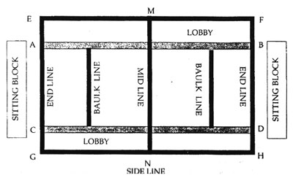
A) Volley Ball
B) Kabadi
C) Basket Ball
D) Beach Volley Ball
83. Identify the theory related to the following picture
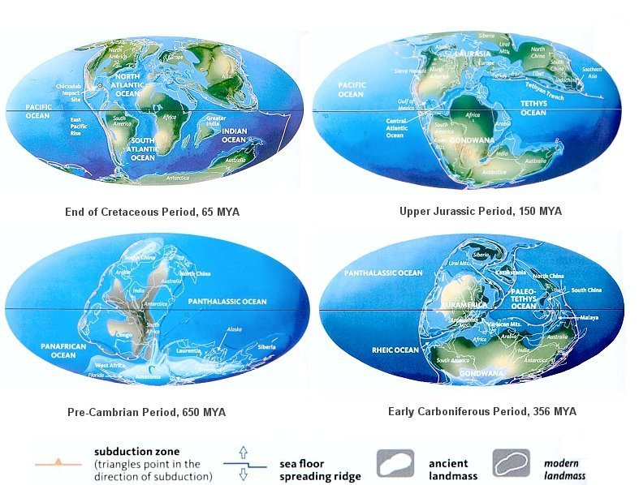
A) Theory of plate tectonics
B) Theory of Continental Drift
C) Erosion Cycle theory
D) Evolution theory

84. Which one of the following picture is not related to Hitler?
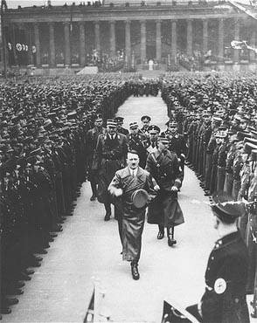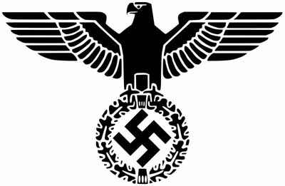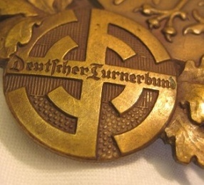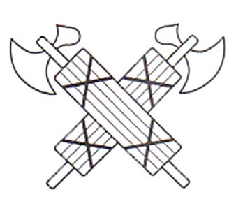
A) B) C) D)

85. Find odd one out:
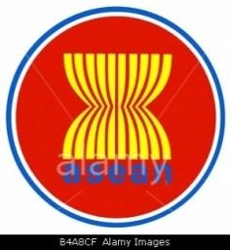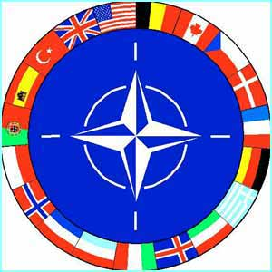
A) B) C) D)
Direction for question No 86 to 90:- In each of the following questions there is a series with one term missing as shown by (?). Find the correct alternative
86. 2 6 12 20 30 42 ?
A) 56 B) 48 C) 60 D) 70
87. 1 3 7 13 21 31 ?
A) 40 B) 46 C) 52 D) 43
88. 11 10 ? 100 1001 1000 10001
A) 101 B) 110 C) 111 D) 1011
89. 1 5 8 10 11 ?
A) 3 B) 11 C) 14 D) 9
90. 0 2 6 12 20 ? 42
A) 25 B) 32 C) 30 D) 38
Direction for question No 91 to 94:- The following problems are on series find the relationship and then decide the next letter or number to replace the question mark.
91. 10J 13M 17Q 20T ?
A) H8 B) 24X C) I9 D) 25Y
92. A D I P ?
A) R B) S C) V D) Y
93. A 3 F 10 ?
A) O B) P C) 15 D) 12

94. D/B H/D L/F P/H ?
A) A/Z B) B/Y C) T/J D) M/N
95. If water is called blue, blue is called red, red is called white, white is called sky, sky is called rain, rain is called green, green is called air, and air is called table which of the following is the colour of milk
A) Green B) Air C) Sky D) Rain
Direction for question No 96 to 100:- Choose out the odd one
96. A) Snake B) Lizard C) Turtle D) Whale
97. A) Silver B) Iron C) Gold D) Zinc
98. A) Carrot B) Radish C) Potato D) Sweet potato
99. A) TS B) WX C) ED D) LK
100. A) Bigger B) Faster C) Larger D) Greater

Space for Rough Works

